Db diagrams

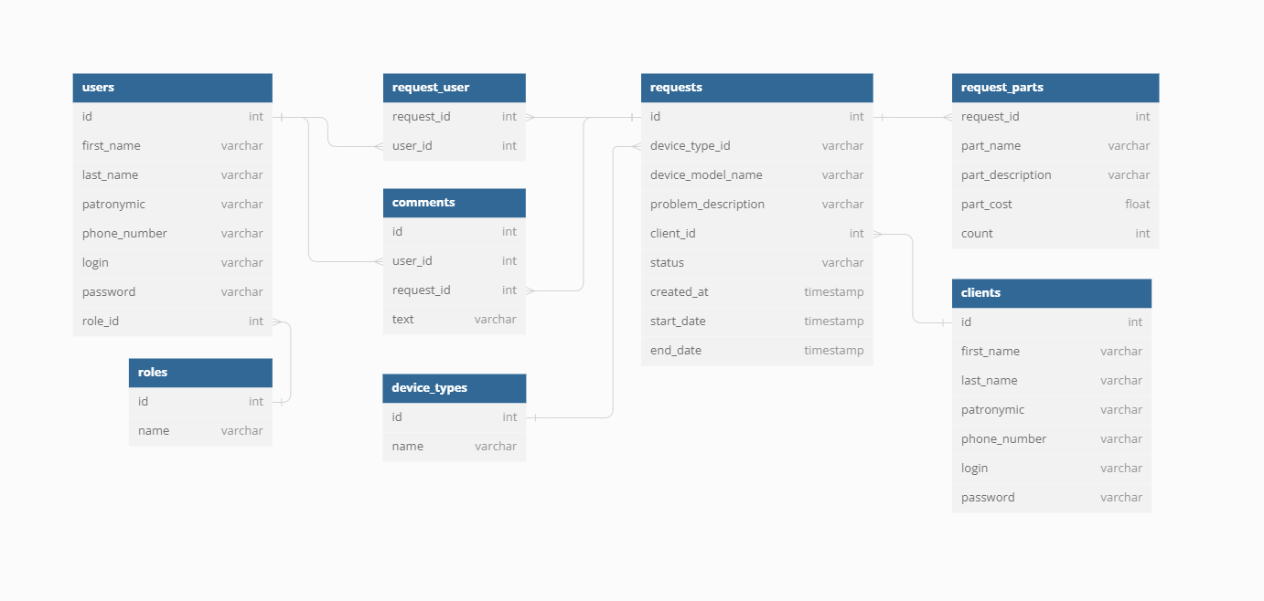[https://dbdiagram.io/d/664b6402f84ecd1d22a8d43c  
https://dbdiagram.io/d/service_center-664b6402f84ecd1d22a8d43c](https://dbdiagram.io/d/664b6402f84ecd1d22a8d43chttps://dbdiagram.io/d/service_center-664b6402f84ecd1d22a8d43c)

[](https://dbdiagram.io/d/664b6402f84ecd1d22a8d43chttps://dbdiagram.io/d/service_center-664b6402f84ecd1d22a8d43c)

ы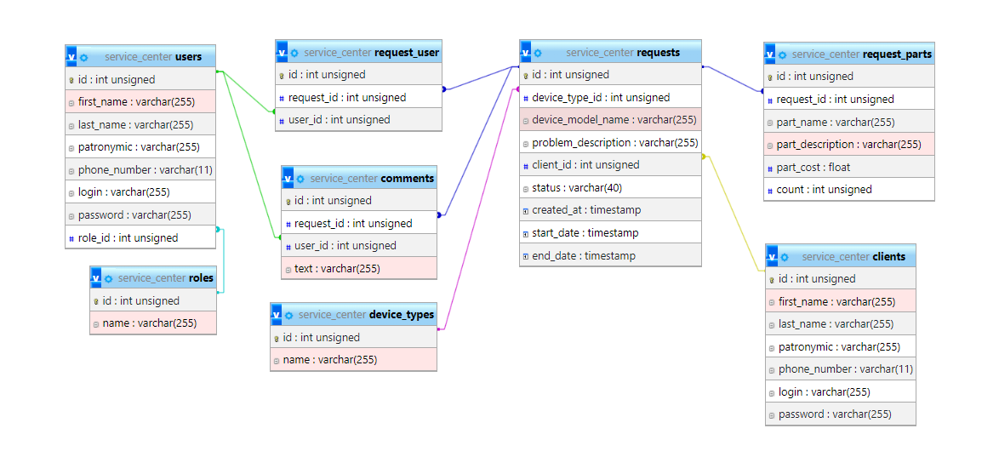

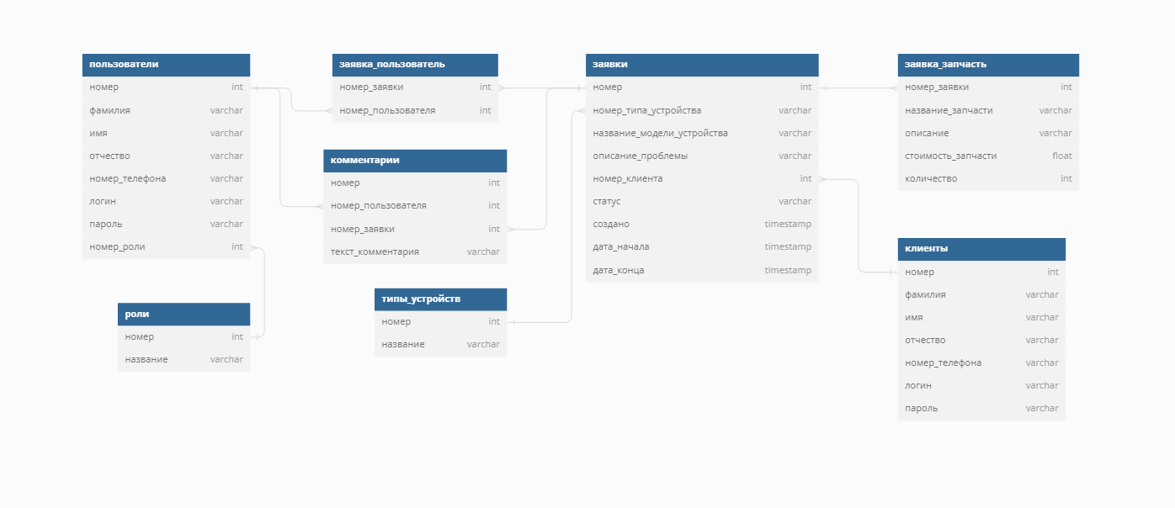

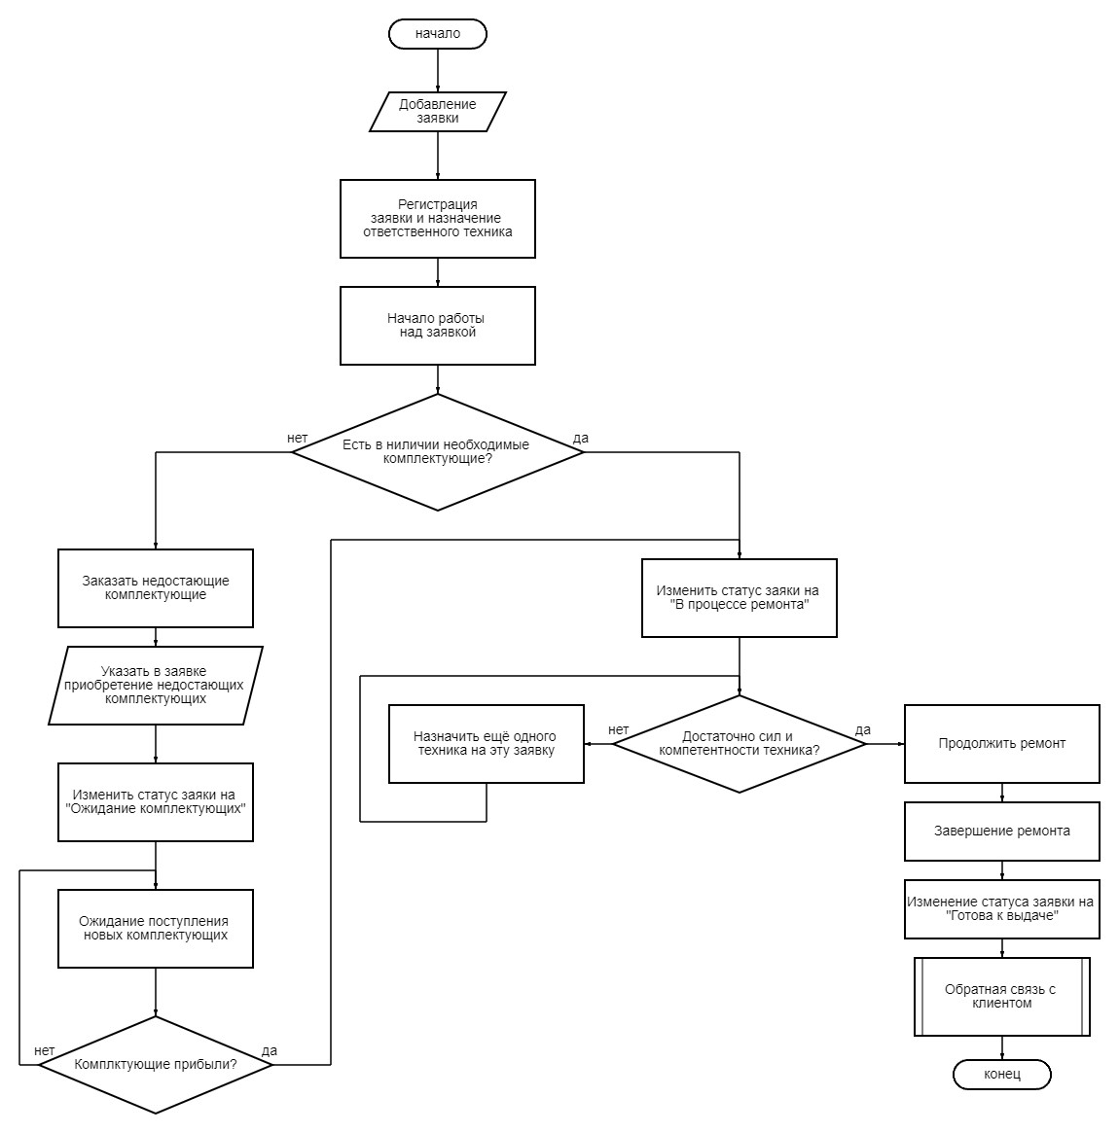

https://programforyou.ru/block-diagram-redactor